Presidents Letter Colina - Nevada

Introduction
The Nevada Division is seeking approval to acquire 292 lots in the Colina community—132 townhome lots (22x60), 81 lots (40x100) and 79 lots (50x105)—from the seller/developer Self, currently under escrow and slated to close on December 15, 2024. This purchase establishes three core-product neighborhoods within a premier master-planned community, provides a two-year lot supply and delivers projected returns of 20.0% net contribution and a 20.1% MIRR. Colina’s resort-style ambiance, above-average school ratings and convenient access to regional recreational amenities underscore the strategic value of this opportunity for the Nevada Division.
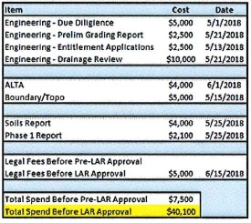
Other: A table listing costs and dates associated with various engineering, survey, soil, and legal items, along with total spend calculations.
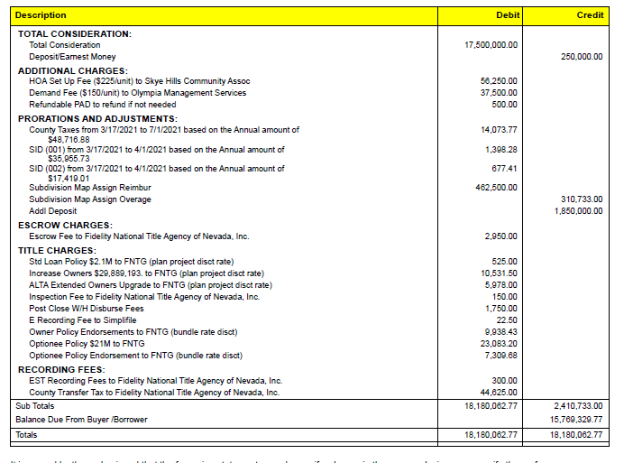
Other: A financial or accounting table listing various charges, fees, and adjustments including debit and credit columns.
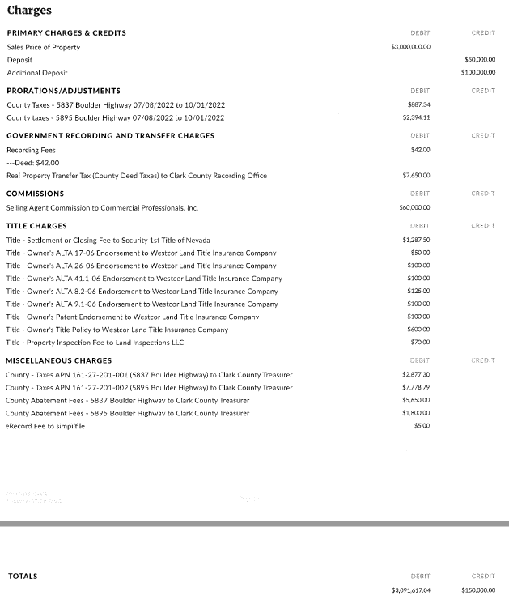
Other: A detailed list of charges and credits related to a property transaction, including sales price, deposits, prorations, government recording fees, commissions, title charges, and miscellaneous charges.
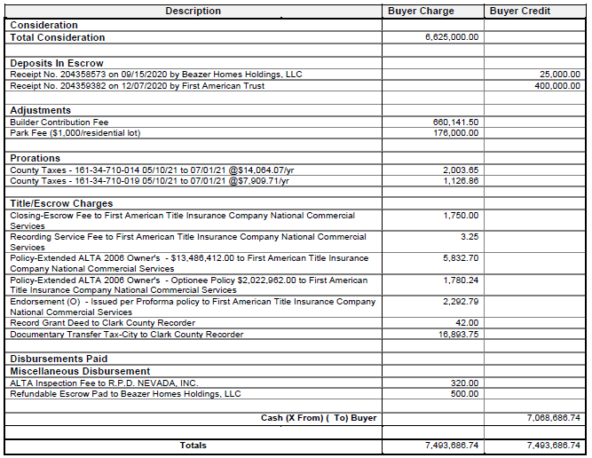
Other: A financial statement or settlement statement detailing various charges, credits, and adjustments related to a real estate transaction.
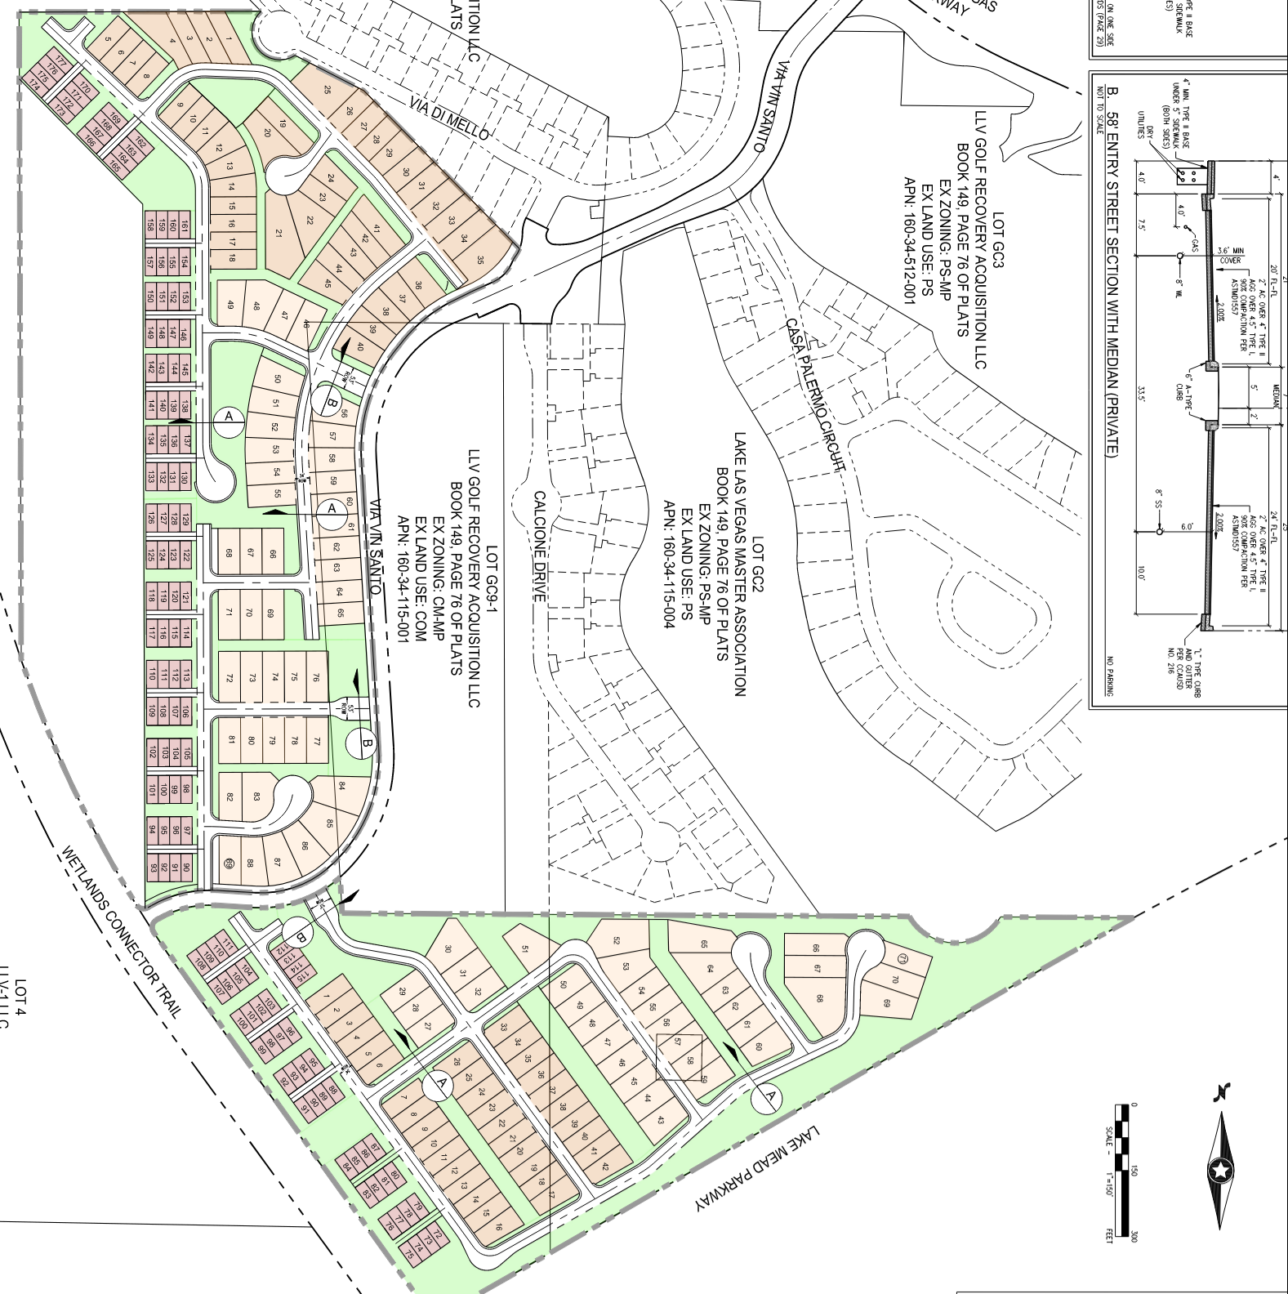
Map View of the Site: A site plan showing various residential lots, streets, and trails with labels and zoning information.

Failed to add image: Image

Deal Structure
Metric | Value
Contract Status | Under Escrow
Developer | Self
Expiration of Due Diligence | 26 Aug 2024
LAR LD Risk | High
Land Status | Raw
Risk Rating | High
Takedown Structure | Bulk
Land Closing LD Risk | High

Financial Summary
The following financial overview for the Colina development in Nevada highlights key metrics from our pro forma analysis. Spanning 292 lots, the project entails a total investment of $50.8 million and an average selling price of $536,830 per lot, resulting in a net contribution margin of 20.0% and a Modified Internal Rate of Return (MIRR) of 20.1%.
Peak capital requirements reach $49 million, with an average capital deployment of $28 million over the development cycle. These capital metrics, together with the robust margin and return profile, underscore the financial strength of the Colina acquisition. Net contribution and MIRR remain the primary indicators of the project’s anticipated success.

Financial Summary
 | TH | 30 | 40 | Land Sale | Total
Lot Size | 22x60 | 40x100 | 50x105 | NA
Lots | 132 | 81 | 79 | 0 | 292
Deposit | $308,511 | $524,469 | $617,022 | N/A | $1,450,000
LOC | N/A | N/A | N/A | N/A | N/A
Land Acq | $10,784,538 | $8,127,306 | $9,188,219 | 0 | $28,100,062
Land Dev | $8,730,639 | $6,563,129 | $7,418,511 | 0 | $22,712,278
Total Spend | $19,515,177 | $14,690,434 | $16,606,729 | 0 | $50,812,339
ASP | $456,490 | $559,223 | $648,110 | N/A | $536,830
Improved Lot Cost | $147,843 | $181,363 | $210,212 |  | $174,015
NC | 18.1% | 20.4% | 21.9% | 0 | 20.0%
MIRR | 19.3% | 20.4% | 20.4% | N/A | 20.1%
Sales Pace | 5.7 | 3.9 | 2.9 | N/A | 4.1
Close of Escrow | 15 Dec 2024 | 15 Dec 2024 | 15 Dec 2024 | N/A | 15 Dec 2024
First Sale | Dec. 2025 | Dec. 2025 | Dec. 2025 | N/A | Dec. 2025
First Home Delivery | Feb. 2026 | Feb. 2026 | Feb. 2026 |  | Feb. 2026

Competitor Analysis
No competitor data was provided, preventing a thorough quantitative or qualitative comparison. Without details on competitor offerings, pricing, market positioning, or performance metrics, it is impossible to identify trends, benchmark strengths or weaknesses, or validate market assumptions. To move forward, data collection on competitor activities and metrics is required.

Key Takeaways
- No competitive pricing structures are available for analysis
- Market positioning and unique selling propositions of competitors are not identified
- Service offerings, feature sets, and coverage areas remain undefined
- Customer acquisition strategies and channel effectiveness cannot be evaluated
- Performance indicators such as occupancy rates, revenue per unit, or customer satisfaction are missing

Strategic Observations
- Prioritize systematic competitor intelligence gathering—leverage industry reports, mystery shopping, or public records
- Establish a data framework capturing pricing, product features, and market presence to enable structured benchmarking
- Implement regular competitor monitoring to inform pricing adjustments and promotional tactics
- Use initial internal audits and client feedback to identify potential differentiation until competitor data is obtained
- Allocate resources to market research tools or partnerships to ensure continuous data-driven strategy refinement

Key Assumptions
The Colina acquisition is underpinned by a stable submarket outlook and strategic positioning within a master-planned community offering resort-style amenities, strong school ratings and convenient access to recreational assets. We have assumed durable USPs, including a solar-standard offering that distinguishes Colina from competing product, and lot premiums of $5,000 on TH homes and $10,000 on both 30' and 40' floorplans. A sales pace of 5.7 homes per month for TH, 3.9 for the 30' product and 2.9 for the 40' product aligns with divisional absorption rates, supporting first closings in December 2025 and home deliveries beginning February 2026. With 292 total lots and a two-year supply, Colina offers the division a resilient position to capture price appreciation and margin enhancement as competition moderates by opening.
Development assumptions include a bulk takedown of raw land under escrow through a December 15, 2024 closing, following due diligence completion by August 26, 2024. Total project investment of $50.8 million comprises $28.1 million in land acquisition and $22.7 million in land development, yielding an improved lot cost of $174,015 and an average selling price of $536,830. Financial underwriting targets a 20.0 percent net contribution and a 20.1 percent MIRR. Strategic opportunities arise from limited current competition in the submarket, the ability to bank land, and the establishment of three distinct product lines—all contributing to a two-year delivery window and strong leverage of the division’s core capabilities.

Risks
There is a risk that market conditions could soften by the time Colina opens for sale in December 2025. Although the Division expects to mitigate this through durable USPs and a solar‐standard offering unmatched by local competitors, absorption rates remain subject to shifts in buyer demand. On the development side, the raw land’s challenging topography and hard‐rock substrate will require extensive mass grading and trenching. While multiple bids have been secured to validate the $22.7 million development budget, unanticipated geological or weather‐related issues could drive cost or schedule overruns and impact the planned first home deliveries in February 2026.
The project’s peak capital requirement of approximately $49 million (with an average capital outlay of $28 million) underscores a financial risk if the intended land‐banking arrangement is not secured. Total land acquisition of $28.1 million and development spending of $22.7 million must be funded through closing, and there is a risk that a land banker may decline participation. Contractually, the acquisition remains under escrow with due diligence expiring August 26, 2024, and closing conditional on the successful reduction of a 1,400­-foot utility easement by December 15, 2024. Any delay in obtaining easement relief or in satisfying closing conditions could postpone sales and home deliveries, adversely affecting projected cash flows and returns.

